**Assignment -1**

|  |  |
| --- | --- |
| Assignment Date | 19 September 2022 |
| Student Name | Gopinath A |
| Student Roll Number | 810019104020 |
| Maximum Marks | 2 Marks |

**Question-1:**

R&D spending: The amount which startups are spending on Research and development.

|  |
| --- |
| **Solution:** |
|  |  |

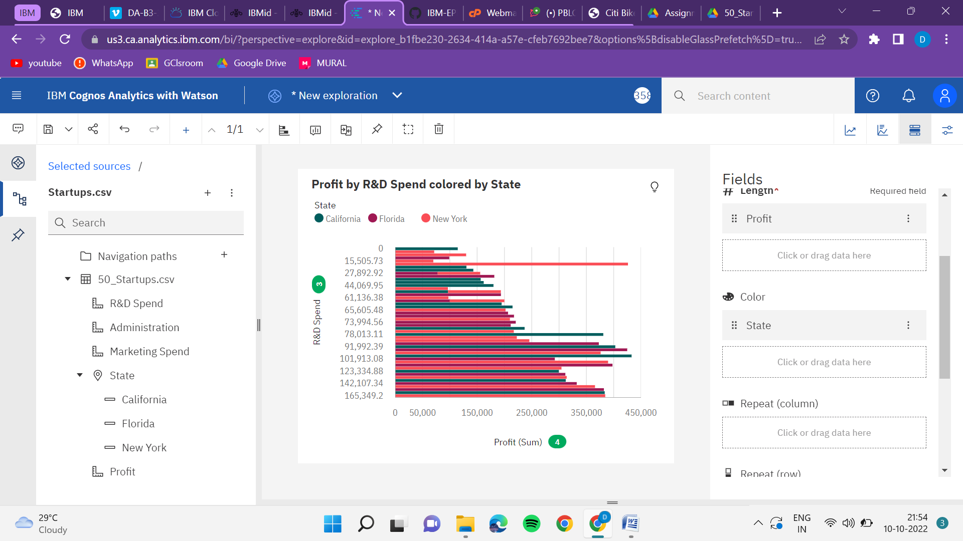

**Question-2:**

Administration spending: The amount which startups are spending on the Admin panel.

|  |
| --- |
| **Solution:** |
|  |  |
|  |  |
|  |  |
|  |  |
|  |  |
|  |  |
|  |  |
|  |  |

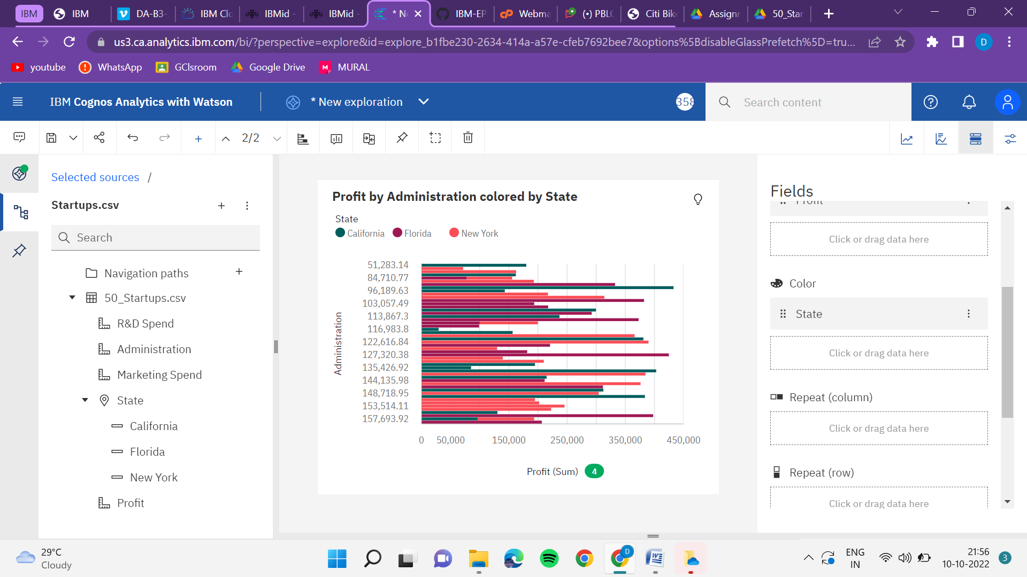

**Question-3:**

3. Marketing spending: The amount which startups are spending on marketing strategies.

**Solution:**

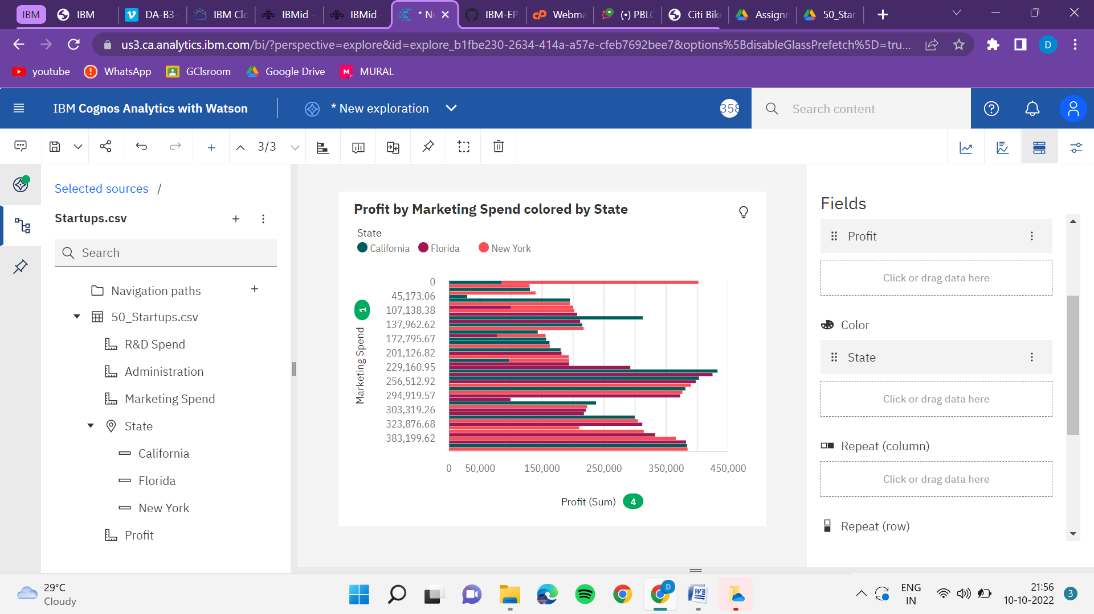

**Question-4:**

**State: To which state that particular startup belongs.**

**Solution:**

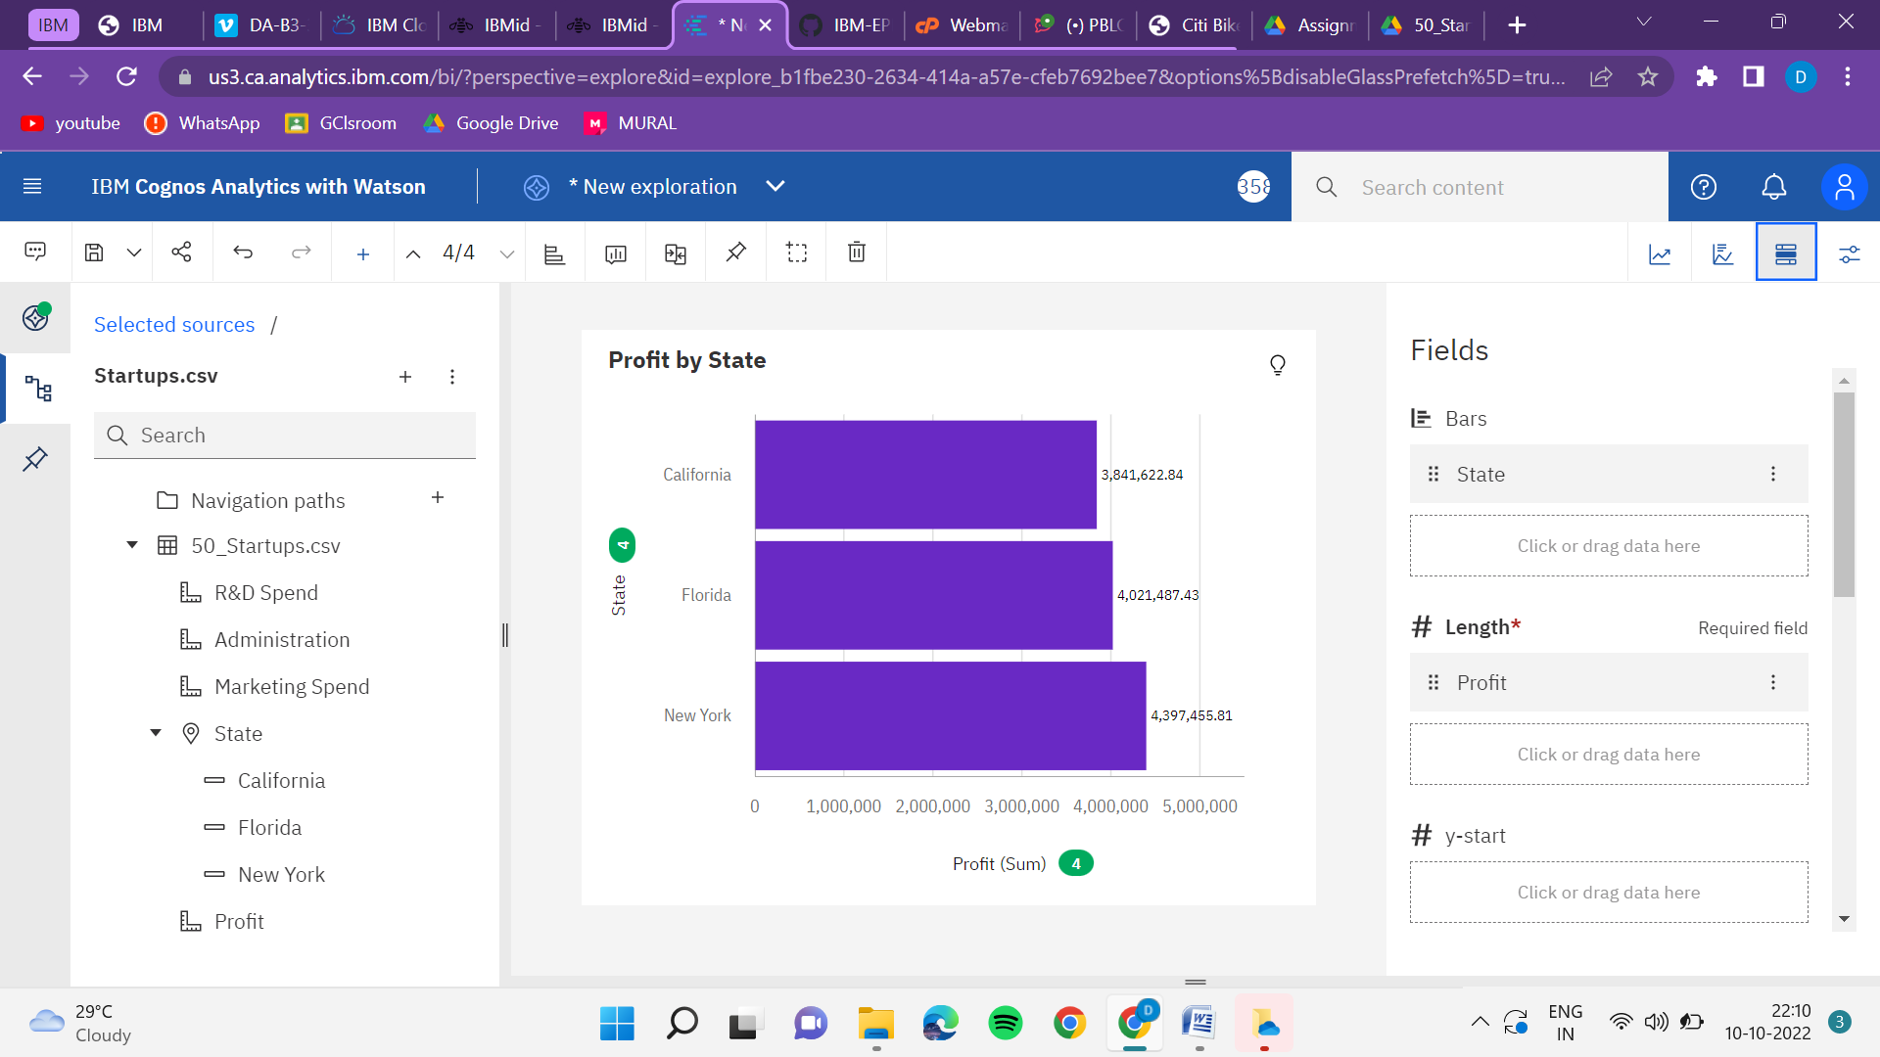

**Question-5:**

Profit: How much profit that particular startup is making.

**Solution:**

